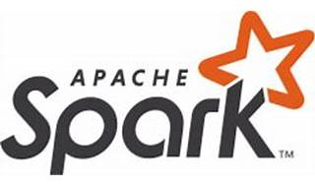

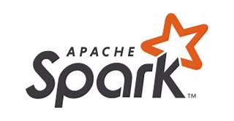

Explore

[Certainly**Apache Spark** is a lightning-fast, open-source data-processing engine used for machine learning and AI applications, backed by a large open-source community in the big data domain](https://aws.amazon.com/what-is/apache-spark/) [1](https://aws.amazon.com/what-is/apache-spark/)[2](https://www.ibm.com/topics/apache-spark)[3](https://www.ibm.com/id-en/topics/apache-spark). It easily handles large-scale data sets and is well-suited for tasks like PySpark.

Here are **five free reference links** where you can learn more about Apache Spark:

1. **AWS Introduction to Apache Spark**: This resource provides an overview of Spark, its features, and how it works. [You’ll find tutorials and examples to get started](https://aws.amazon.com/what-is/apache-spark/) [1](https://aws.amazon.com/what-is/apache-spark/).
2. [**IBM’s Explanation of Apache Spark**: IBM offers insights into Spark’s capabilities, including its use for machine learning, AI, and real-time data processing](https://aws.amazon.com/what-is/apache-spark/) [2](https://www.ibm.com/topics/apache-spark).
3. [**Google Cloud’s Overview of Apache Spark**: Learn about Spark’s unified analytics engine, its modules (SQL, streaming, machine learning, and graph processing), and its compatibility with various data sources](https://aws.amazon.com/what-is/apache-spark/) [4](https://cloud.google.com/learn/what-is-apache-spark).
4. **Apache Spark Official Documentation**: The official Spark website offers comprehensive documentation, tutorials, and quick-start guides. [You can explore Spark’s features, architecture, and APIs](https://aws.amazon.com/what-is/apache-spark/) [5](https://spark.apache.org/).
5. **Udemy’s Spark Starter Kit**: This free Udemy course delves into Spark in depth, providing a strong foundation. [It covers essential concepts and practical examples](https://aws.amazon.com/what-is/apache-spark/) [6](https://www.udemy.com/course/sparkstarterkit/).

Feel free to explore these resources to enhance your understanding of Apache Spark! 🚀